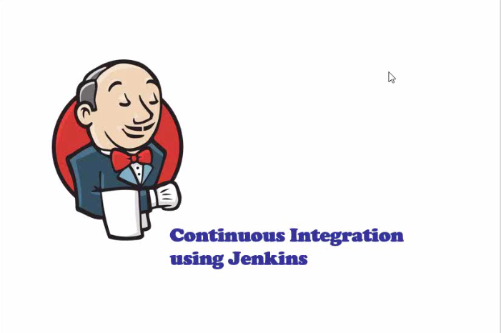

What is Jenkins?

Jenkins is a self-contained, open source automation server which can be used to automate all sorts of tasks related to building, testing, and delivering or deploying software. Jenkins can be installed through native system packages, Docker, or even run standalone by any machine with a Java Runtime Environment (JRE) installed.

Jenkins Installation: Using GUI Mode

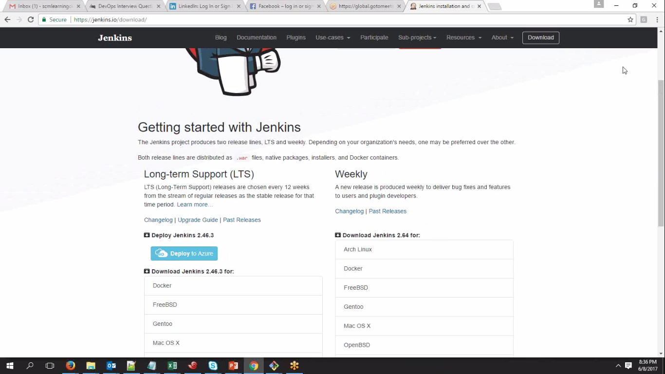

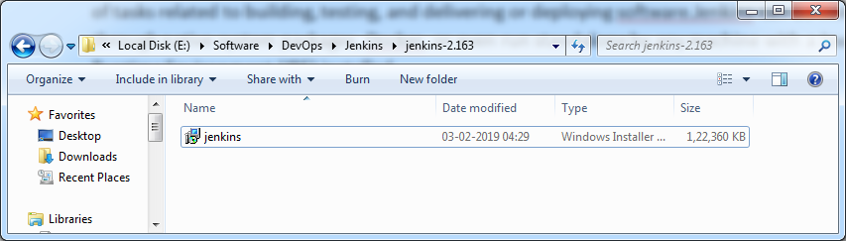

Run the Jenkins.exe shown in above SS

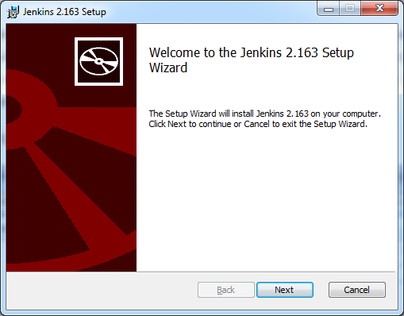

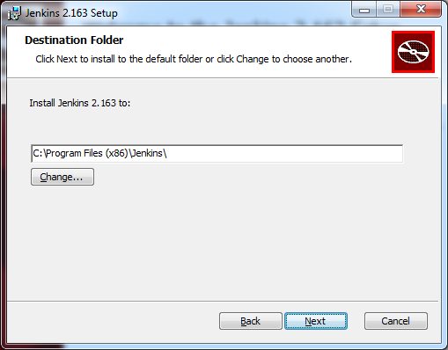

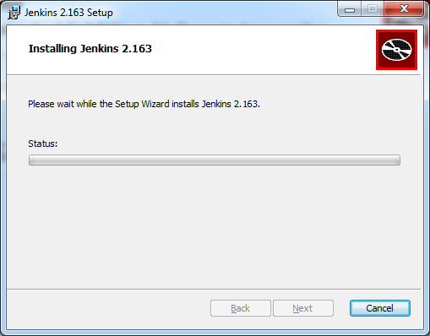

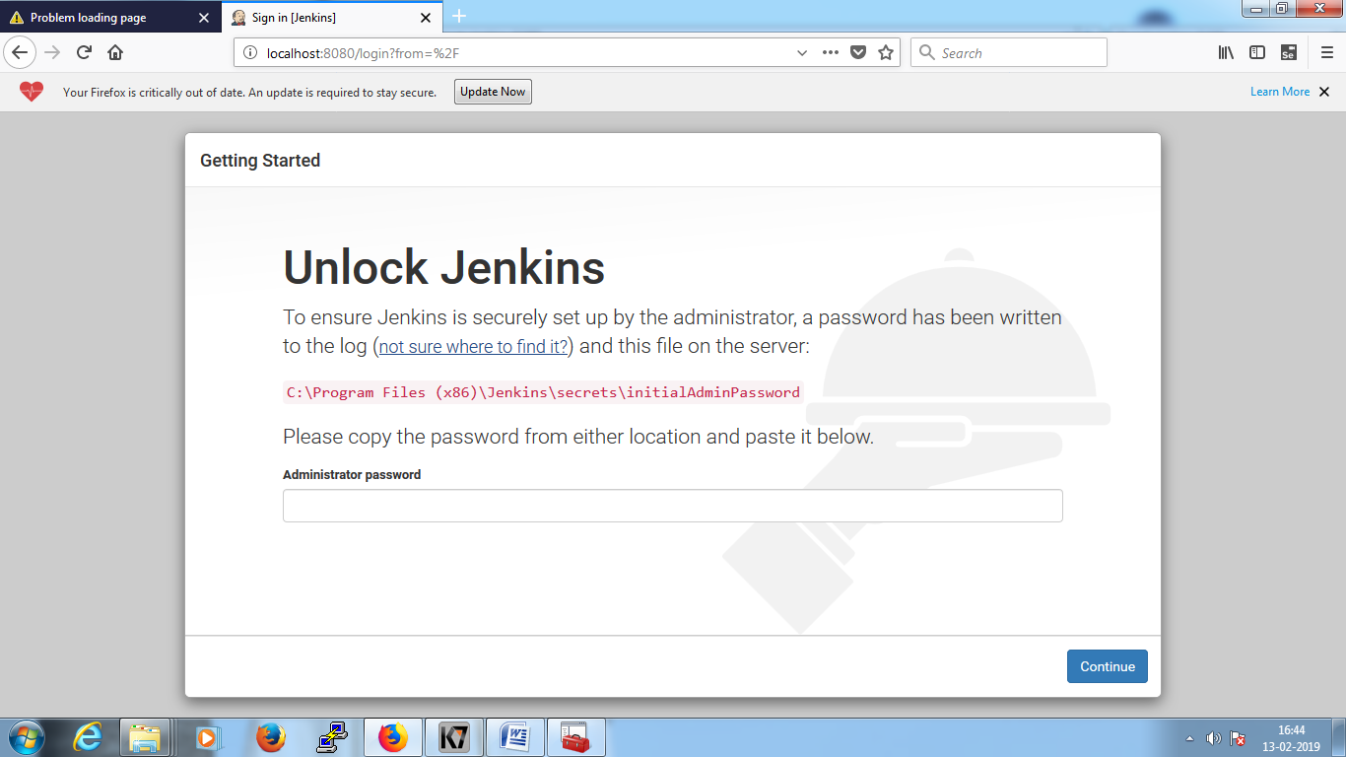

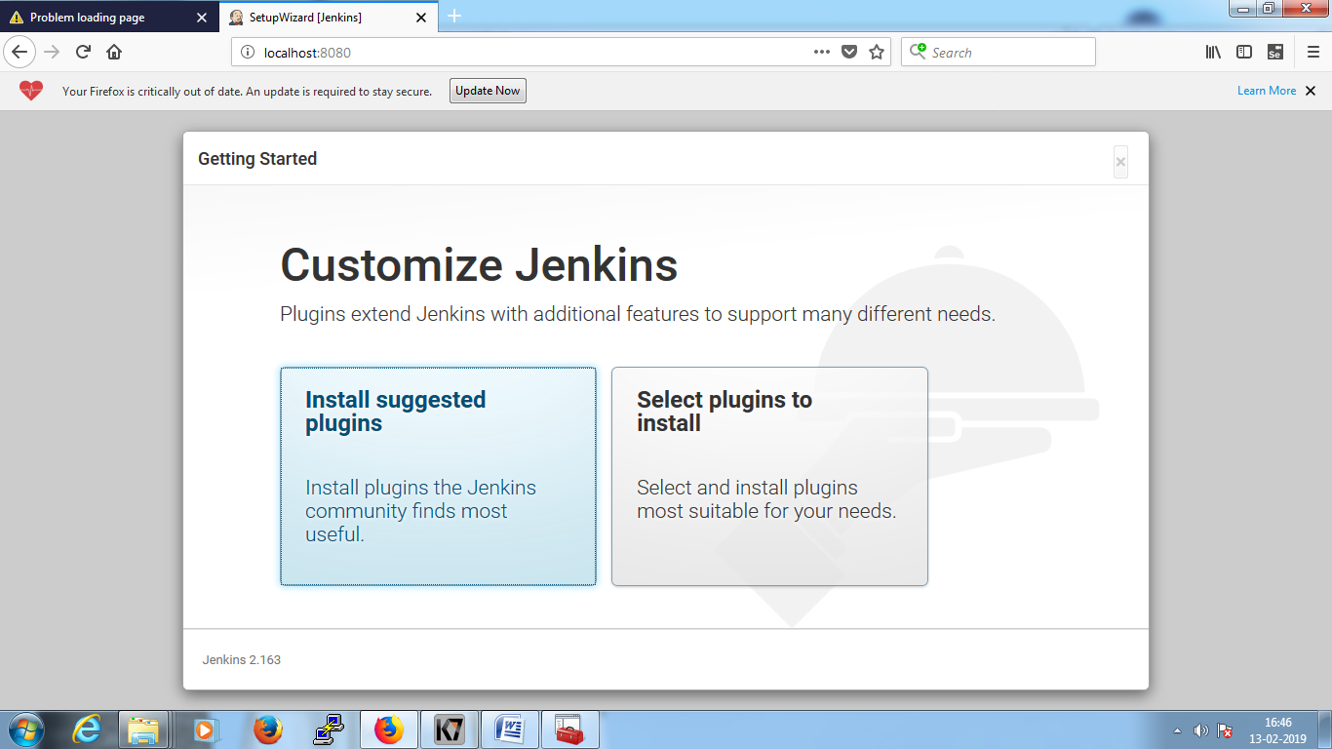

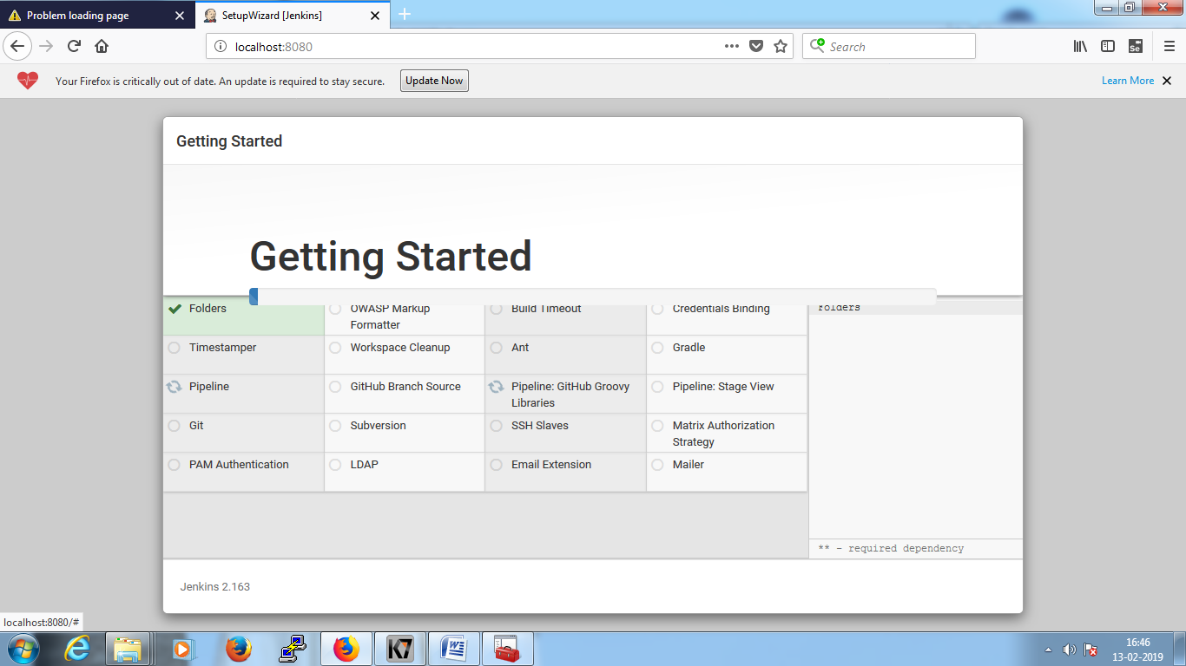

Above Screen will install all default recommend plug-in and other details and moves to below screen.

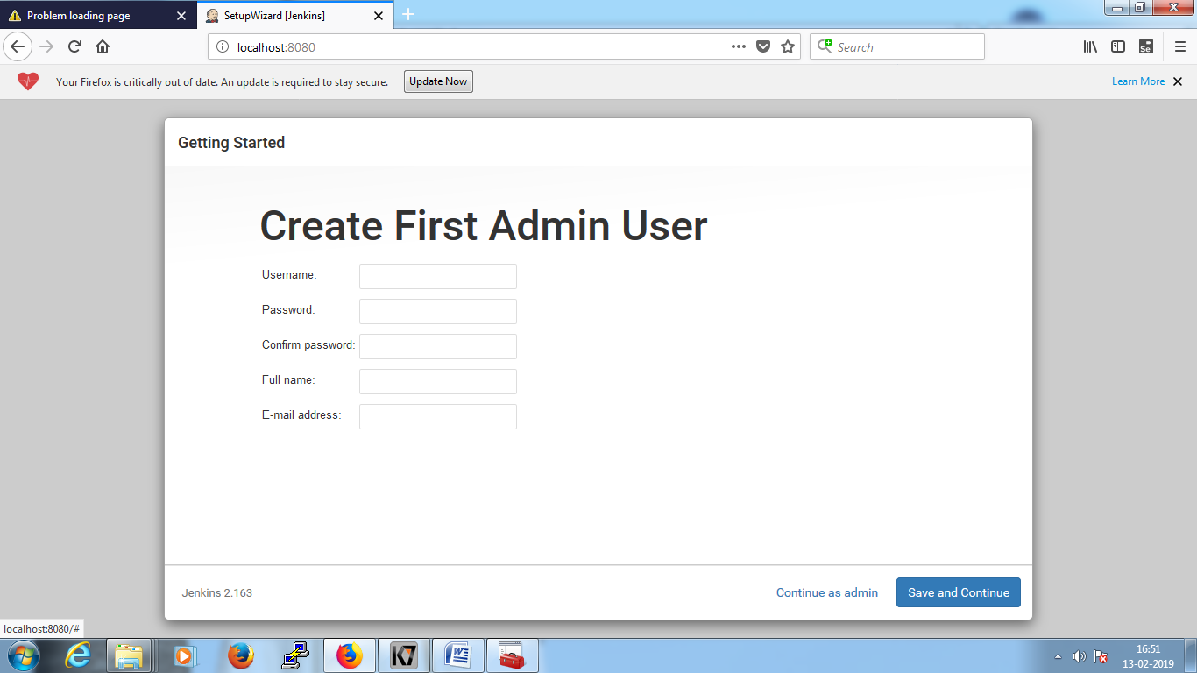

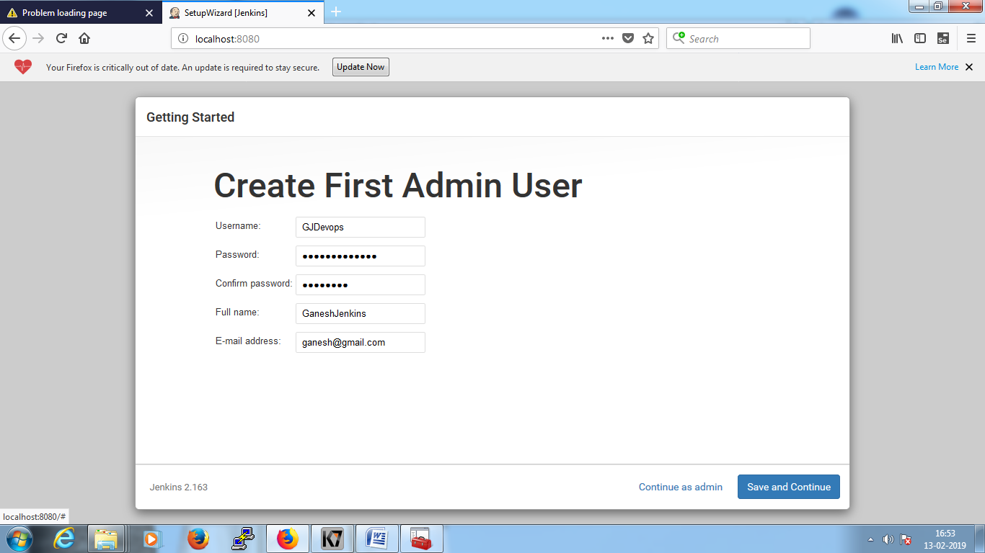

GJDevops@1234

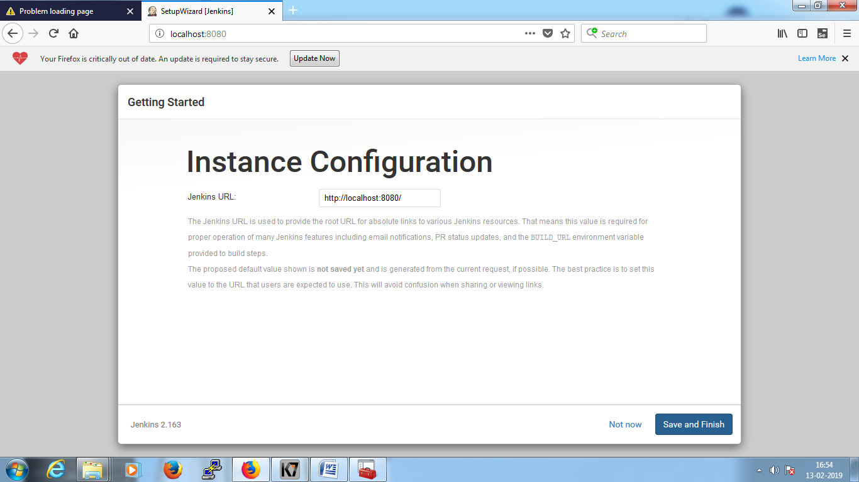

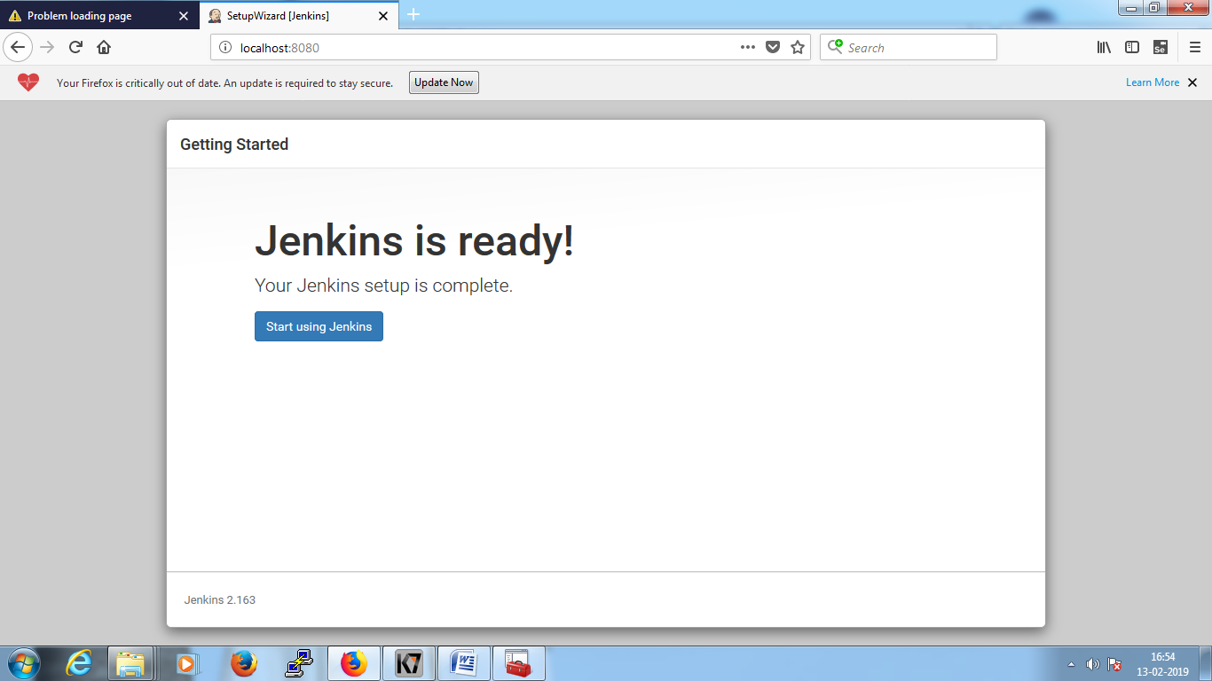

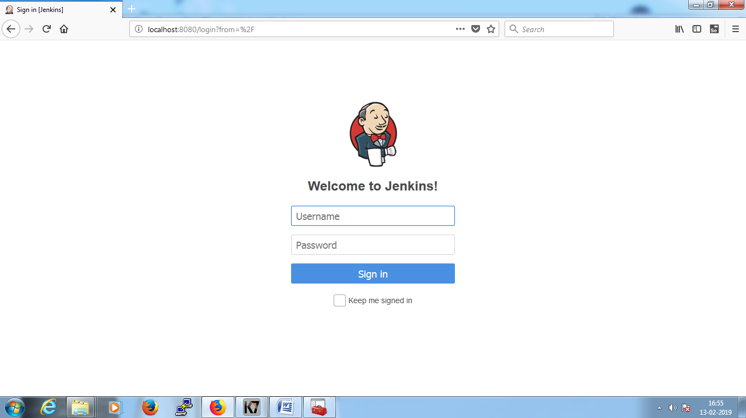

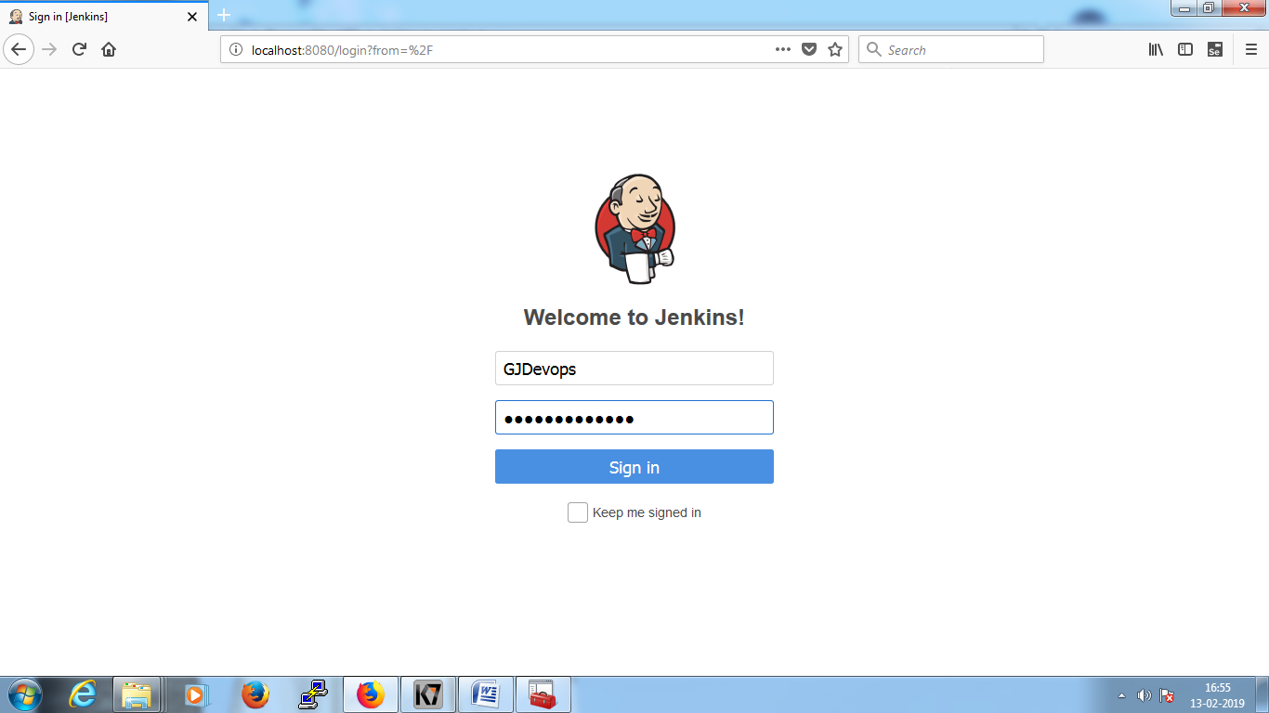

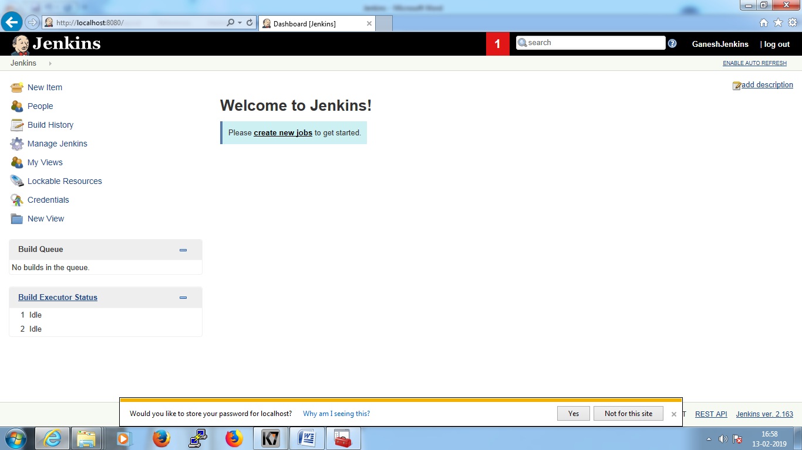

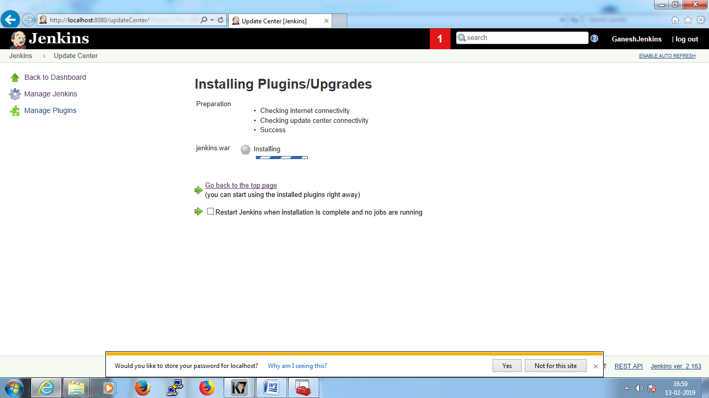

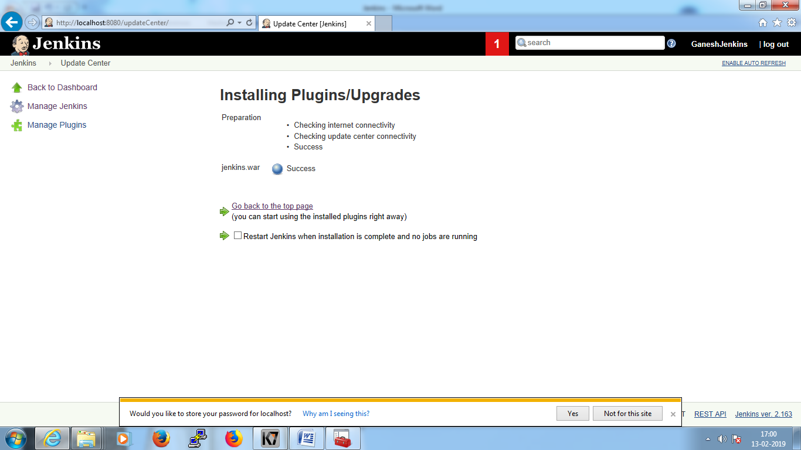

Java –jar Jenkins.war

Java –jar Jenkins.war –httpPort=8087

Downloading Process:

Jenkins.xml: this file contains port details of Jenkins default port <arguments>.

To Stop Jenkins server: using services, 3 types are there

Note: - If you need more plug-ins it requires much space as usual for more files more storage required.

Normally, Jenkins is quite light weight tool.

**Installing Jenkins in Linux:**

<https://www.linuxtechi.com/install-configure-jenkins-on-centos-7-rhel-7/>

Step 1 : Download repository of jenkins to the server where you want to install and import it into yum repository , after install repository using yum installation manager.

sudo wget -O /etc/yum.repos.d/jenkins.repo <https://pkg.jenkins.io/redhat-stable/jenkins.repo>

sudo rpm --import https://pkg.jenkins.io/redhat-stable/jenkins.io.key

**Step 2: Install Jenkins and Java: ( If already jdk installed not required)**

yum install jenkins

Loaded plugins: downloadkvmonly-background, ibm-check-lotus-updates, ibm-check-

: upgrade, ibm-check-xorg-updates, ibm-repository, langpacks,

: post-transaction-actions, refresh-packagekit, versionlock

jenkins | 2.9 kB 00:00

jenkins/primary_db | 30 kB 00:00

Resolving Dependencies

--> Running transaction check

---> Package jenkins.noarch 0:2.204.1-1.1 will be installed

--> Finished Dependency Resolution

Dependencies Resolved

================================================================================

Package Arch Version Repository Size

================================================================================

Installing:

jenkins noarch 2.204.1-1.1 jenkins 60 M

Transaction Summary

================================================================================

Install 1 Package

Total download size: 60 M Installed size: 61 M Is this ok [y/d/N]: y

Downloading packages:

jenkins-2.204.1-1.1.noarch.rpm | 60 MB 00:06

Running transaction check

Running transaction test , Transaction test succeeded ,Running transaction

Installing : jenkins-2.204.1-1.1.noarch 1/1

Verifying : jenkins-2.204.1-1.1.noarch 1/1

Installed:

jenkins.noarch 0:2.204.1-1.1

Complete!

step 3: Start and Enable Jenkins Service:

systemctl start/stop jenkins

systemctl enable jenkins

O/P : jenkins.service is not a native service, redirecting to /sbin/chkconfig.

Executing /sbin/chkconfig jenkins on

Step 4: Access the jenkins web Portal

<http://localhost:8080/>

# **Unlock Jenkins**

To ensure Jenkins is securely set up by the administrator, a password has been written to the log ([not sure where to find it?](https://jenkins.io/redirect/find-jenkins-logs)) and this file on the server:

/var/lib/jenkins/secrets/initialAdminPassword

Please copy the password from either location and paste it below.

After login select

**YUM**(Yellowdog Updater Modified) is an open-source command-line as well as a graphical based package management tool for RPM (RedHat Package Manager) based **Linux** systems. It allows users and system administrators to easily install, update, remove or search software packages on a system